

Department of Computer Science

University of Gujrat

TITLE

LOGO

Session: BSCS ____

Project Advisor: XYZ

Submitted By

XYZA | 1476147-0909
XYZB | 141561-09767

STATEMENT OF SUBMISSION

This is certify that _____________ Roll No. ____________ and _______________ Roll No. ______________ has successfully completed the final year project named as_____________ at the Department of Computer Science, University of Gujrat, to fulfill the requirement of the degree of _______ in Computer Science.

______________________ _____________________
Project Supervisor Project Coordination Office
Faculty of C&IT -UOG

______________________
Chairperson
Department of Computer Science

Acknowledgement

We truly acknowledge the cooperation and help make by ________________, Chairman, Department of Computer Science, University of Gujrat. He has been a constant source of guidance throughout the course of this project. We would also like to thank _____________________ for his help and guidance throughout this project. We are also thankful to our friends and families whose silent support led us to complete our project.

Date:

Abstract

Due to ever increasing demand of transporting huge amount of information generated from various sources such as voice, data, video, etc., modern telecommunication networks have been transformed into all digital and broadband. Depending on the characteristics of information sources and the availability of facility, the mode of transportation can be either constant bit rate (CBR) using circuit switched networks or variable bit rate (VBR) using packet switched networks. For efficient utilization of the network, all kinds of information can be transported using BISDN (Broadband Integrated Services Digital Network) and ATM (Asynchronous Transfer Mode) technology. One important research area in Network Technology is the design of high-speed digital network with good performance. The issues need to be investigated include modeling of Variable Bit Rate video traffic, efficient assignment of different traffic classes with diverse quality of services, optimal bandwidth allocation, routing and call admission control etc. This project not only relates to study of Digital Subscriber Line, which is a Broadband technology to provide high-speed data, voice and video but also addresses the above-mentioned issues. What are the provisions made in DSL implement QoS quality of service.

TABLE OF CONTENTS
CHAPTER 1: PROJECT FEASIBILITY REPORT 7
1.1. Introduction 8
1.2. Project/Product Feasibility Report 8
1.2.1. Technical Feasibility 8
1.2.2. Operational Feasibility 8
1.2.3. Economic Feasibility 8
1.2.4. Schedule Feasibility 9
1.2.5. Specification Feasibility 9
1.2.6. Information Feasibility 9
1.2.7. Motivational Feasibility 9
1.2.8. Legal & Ethical Feasibility 9
1.3. Project/Product Scope 9
1.4. Project/Product Costing 9
1.5. Task Dependency Table 9
1.6. CPM - Critical Path Method 10
1.7. Gantt chart 11
1.8. Allocation of Members to Activities 11
1.9. Tools and Technology with reasoning 12
1.10. Vision Document 12
1.11. Product Features/ Product Decomposition 13
CHAPTER 2: SOFTWARE REQUIREMENT SPECIFICATION (FOR OBJECT ORIENTED APPROACH) 14
2.1 Introduction: 15
2.2 Systems Specifications 15
2.2.1. Identifying External Entities 15
2.2.2. Context Level Data Flow Diagram: 15
2.2.3. Capture "shall" Statements: 15
2.2.4 Allocate Requirements: 16
2.2.5. Prioritize Requirements (If Any): 18
2.3. Existing Systems / Literature Review: 21
2.3.1. Existing System 21
2.4. Usecase Diagram of Your Project: 22
2.4.1. Usecase Description 24
CHAPTER 3: DESIGN DOCUMENT (FOR OBJECT ORIENTED APPROACH) 25
3.1. Introduction: 26
3.2. Domain Model 26
3.3. Design Class Diagram 27
3.4. Sequence Diagram 29
3.5. State chart diagram 30
3.6. Collaboration Diagram 30
a. Contents of Collaboration Diagrams 31
CHAPTER 4: USER INTERFACE DESIGN 32
4.1. Introduction 33
4.2. Site Maps 33
4.3. Story boards 33
4.4. Navigational maps: 35
CHAPTER 5: SOFTWARE TESTING 36
5.1 Introduction: 37
5.2. Test plan 37
5.2.1. Purpose 37
5.2.2. Outline 37
5.3. Test design specification 41
5.3.1. Purpose 41
5.3.2. Outline 41
5.4. Test Case Specification 44
5.4.1. Purpose 44
5.4.2. Outline 44
5.5. Test procedure specification 46
5.5.1. Purpose 46
5.5.2 Outline 46
5.6. Test item transmittal report 48
5.6.1. Purpose 48
5.6.2. Outline 48
5.7. Test log 49
5.7.1. Purpose 49
5.7.2. Outline 49
5.8. Test incident report 50
5.8.1. Purpose 50
5.8.2. Outline 50
5.9. Test summary report 51
5.9.1. Purpose 51
5.9.2. Outline 51
CHAPTER 7: RESULTS 53
CHAPTER 8: USER MANUAL 54
CHAPTER 9: CONCLUSION AND FUTURE WORK 55

Chapter 1: Project Feasibility Report

1.1. Introduction

1.2. Project/Product Feasibility Report
When a project is started the first matter to establish is to assess the feasibility of a project or product. Feasibility means the extent to which appropriate data and information are readily available or can be obtained with available resources such as staff, expertise, time, and equipment. It is basically used as a measure of how practical or beneficial the development of a software system will be to you (or organization). This activity recurs throughout the life cycle.
There are many types of feasibilities:

- Technical
- Operational
- Economic
- Schedule
- Specification
- Information
- Motivational
- Legal and Ethical

1.2.1. Technical Feasibility
Technical Feasibility deals with asking the question as to whether the system can be developed or not. It is one of the most important questions before starting the project because it is assessing the limits of theory or technology applicable to the project. Another important query to be answered is to evaluate whether you (the project members or organization) possess the technology and technical expertise.

1.2.2. Operational Feasibility
Evaluation of technical ability of the staff to operate the project is the main aim of operational feasibility. In this area the question arises as to whether the problem is worth solving and if the solution provided for the problem works or not. How do end users and managers feel about the problem or solution is another query to be answered.

1.2.3. Economic Feasibility
Justification for the benefit/cost analysis relative to the project is to be measured in economic feasibility. Therefore, economic feasibility can be divided into two parts; cost estimates and benefit estimates. Cost estimates can further be alienated into development or acquisition costs (one time) and maintenance and operation costs (ongoing). In order to find development costs, break the project into tasks and use the lifecycle cost models. Experienced costs gained from similar projects should then be used to make estimates. The function point metric should be calculated.
Benefit estimates enclose tangible benefits and intangible benefits. Tangible benefits would include reduced costs and increased revenues. However, information quality, job satisfaction, and external standing are examples of intangible benefits.

1.2.4. Schedule Feasibility
Time is an important factor. The assessment and evaluation of the completion of a project with the available staff and resources within time is very essential. Meeting deadlines and milestones should always be kept in mind.

1.2.5. Specification Feasibility
Requirements are the features that the system must have or a constraint that must be accepted for the customer. The question arises as to whether the requirements are clear and definite. The scope boundaries must also be assessed.

1.2.6. Information Feasibility
The feasibility of information must be assessed regarding its completion, reliability, and meaningfulness.

1.2.7. Motivational Feasibility
Evaluation of the client staff regarding the motivation to perform the necessary steps correctly and promptly must occur.

1.2.8. Legal & Ethical Feasibility
”Do any infringements or liabilities arise from this project? “ is the main focus of this feasibility.

1.3. Project/Product Scope
Scope is a very dominant factor. Scope and context are both intertwined as both involve the boundaries of a system. Context would be referring to what holds outside the boundary the system. While scope would indicate whatever is inside the boundary of the system.
The scope of a project is defined by the set of requirements allocated to it. Managing project scope to fit the available resources (time, people, and money) is key to managing successful projects. Managing scope is a continuous activity that requires iterative or incremental development, which breaks project scope into smaller more manageable pieces.
Using requirement attributes, such as priority, effort, and risk, as the basis for negotiating the inclusion of a requirement is a particularly useful technique for managing scope. Focusing on the attributes rather than the requirements themselves helps desensitize negotiations that are otherwise contentious.

1.4. Project/Product Costing
Write According to your project.

1.5. Task Dependency Table
The following are the steps to develop a task dependency table:
1. Brainstorm for all of the tasks necessary to complete your project, or take the output from a Tree Diagram that you have already produced.

2. Write each task on a Post-It Note or job card.

3. Establish which task is the first one that must be carried out and place its card on the left hand side of a large work surface.

4. Determine whether there are any tasks that can be done at the same time, i.e. tasks that are not dependent on this first task finishing before they can be carried out. If there are, place their job cards vertically above or below the first job card.

5. Then decide which is the next task that must be carried out and place its card on the right of the first card. Determine whether there are any tasks that can be done at the same time as this task. If there are, place their job cards vertically above or below its job card.

6. Repeat the process until all of the job cards have been arranged in sequence and in parallel.

1.6. CPM - Critical Path Method
As the project progresses, the actual task completion times will be known and the network diagram can be updated to include this information. A new critical path may emerge, and structural changes may be made in the network if project requirements change.
Example:

Activity | Immediate Predecessor | Duration (Weeks)
A | None | 5
B | None | 3
C | A | 8
D | A, B | 7
E | None | 7
F | C, D, E | 4
G | F | 5

D

E

B

A

C

F

G

End

Start

1.7. Gantt chart
The Gantt chart enumerates the activities to be performed on the vertical axis and their corresponding duration on the horizontal axis. It is possible to schedule activities by either early start or late start logic. In the early start approach, each activity is initiated as early as possible without violating the precedence relations. In the late start approach, each activity is delayed as much as possible as long as the earliest finish time of the project is not compromised.
Based on the Work Breakdown Structure (WBS), a timeline or Gantt chart showing the allocation of time to the project phases or iterations should be developed. This Gantt chart would identify major milestones with their achievement criteria. It must contain duration estimation of all the necessary activities to be carried out during the project development along with the human resources responsible for the respective tasks. Activity dependencies are also required to be mentioned in it.

1.8. Allocation of Members to Activities
A brief but a concise introduction of the team members should be provided signifying their skill set. This skill set would especially be representative of the tasks and activities assigned to him.

Task | Duration (days) | Dependencies
T1 | 8
T2 | 15
T3 | 15 | T1(M1)
T4 | 10
T5 | 10 | T2, T4(M2)
T6 | 5 | T1, T2 (M3)
T7 | 20 | T1 (M1)
T8 | 25 | T4 (M5)
T9 | 15 | T3, T6 (M4)
T10 | 15 | T5, T7 (M7)
T11 | 7 | T9 (M6)
T12 | 10 | T11 (M8)

Consider the set of activities shown in figure. This table shows activities, their duration, and activity interdependencies. From figure, you can see that Task T3 is dependent on Task T1. This means that T1 must be completed before T3 starts. For example, T1 might be the preparation of a component design and T3, the implementation of that design. Before implementation starts, the design should be complete.

1.9. Tools and Technology with reasoning
The application tools, which are to be used on front and back end of the system to be developed, should be listed. The reasons for these tools should also be described.
Identify what the needs for tool support are, and what the constraints are, by looking at the following:
- The development process. What tool support is required to effectively work? For example, if the organization decide to employ an iterative development process, it is necessary to automate the tests, since you will be testing several times during the project.
- Host (or development) platform(s).
- Target platform(s).
- The programming language(s) to be used.
- Existing tools. Evaluate any existing and proven tools and decide whether they can continue to be used.
- The distribution of the development organization. Is the organization physically distributed? Development tools generally support a physically distributed organization differently.
- The size of the development effort. Tools support large organizations more or less well.
- Budget and time constraints

1.10. Vision Document
The Vision defines the stockholder’s view of the product to be developed, specified in terms of the stockholder’s key needs and features. Containing an outline of the envisioned core requirements, it provides the contractual basis for the more detailed technical requirements.
A Vision Document is the starting point for most software projects. It is the primary deliverable and is therefore the first document produced in the planning process. The main purpose of this document is to move the project forward into detailed project planning and ultimately into development.
The Vision Document is designed to make sure that key decision makers on both sides have a clear, shared vision of the objectives and scope of the project. It identifies alternatives and risks associated with the project. Finally, it presents a budget for the detailed planning phase for the stakeholders to approve.
The Vision document provides a high-level for the more detailed technical requirements. There can also be a formal requirements specification. The Vision captures very high-level requirements and design constraints to give the reader an understanding of the system to be developed. It provides input to the project-approval process and is, therefore, intimately related to the Business Case. It communicates the fundamental "whys and what's" related to the project and is a gauge against which all future decisions should be validated.
A project vision is meant to be changeable as the understanding of requirements, architecture, plans, and technology evolves. However, it should be changing slowly and normally throughout the earlier portion of the lifecycle.
It is important to express the vision in terms of its use cases and primary scenarios as these are developed, so that you can see how the vision is realized by the use cases. The use cases also provide an effective basis for evolving a test case suite.
Another name used for this document is the Product Requirement Document. There are certain checkpoints that help to verify that the vision document is fulfilled.
Checkpoints:
- Have you fully explored what the "problem behind the problem" is?
- Is the problem statement correctly formulated?
- Is the list of stakeholders complete and correct?
- Does everyone agree on the definition of the system boundaries?
- If system boundaries have been expressed using actors, have all actors been defined and correctly described?
- Have you sufficiently explored constraints to be put on the system?
- Have you covered all kinds of constraints - for example political, economic, and environmental?
- Have all key features of the system been identified and defined?
- Will the features solve the problems that are identified?
- Are the features consistent with constraints that are identified?

1.11. Product Features/ Product Decomposition
Functional requirements capture the intended behavior of the system. This behavior may be expressed as services, tasks or functions the system is required to perform.

Chapter 2: Software Requirement Specification (For Object Oriented Approach)

2.1 Introduction:
Requirements engineering process provides the appropriate mechanism for understanding what the customer wants, analyzing need, assessing feasibility, negotiating a reasonable solution, specifying the solution unambiguously, validating the specification and managing the requirements as they are transformed into an operational system. The task of capturing, structuring, and accurately representing the user's requirements so that they can be correctly embodied in systems which meet those requirements (i.e. are of good quality).

- Requirements elicitation
- Requirements analysis and negotiation
- Requirements specification
- System modeling
- Requirements validation
- Requirements management

2.2 Systems Specifications
The following are the clauses that must be included while describing the system specifications.

2.2.1. Identifying External Entities
The identification of the external entities will be based on the information contained in your Abstract. This identification is done after two phases. We will map the “Green wood” case study to make things more comprehensible.
The Identification of External Entities is done in two phases.

2.2.2. Context Level Data Flow Diagram:
Context level data flow diagram contains only one process, representing the entire system. The process is given the number zero and all external entities are shown on the context diagram as well as major data flow to and from them. The diagram does not contain any data stores.

2.2.3. Capture "shall" Statements:
Identify “shall” statements, as they would be all functional requirements.
Para # | Initial Requirements
1.0 | A customer “shall” place order for goods
1.0 | A customer “shall” register himself to the system
1.0 | The system “shall” provide two types of registration process, normal and privileged
1.0 | CA “shall” accept, reject and temporarily waive the requests on the basis of credentials provided.
1.0 | A customer “shall” login to the system and can change his password
1.0 | System “shall” update the customers Request
1.0 | System “shall” process different types of updating e.g. updating of his personal/shipping details, or upgrading of his status from registered to privileged customer, or updating of his payment methodology
1.0 | A customer “shall” view his details for verification purposes
1.0 | CA “shall”accept, reject and temporarily waive the requests on the basis of credentials provided.
1.0 | System “shall” search any customer details
2.0 | Both registered and privileged customers “will”order for goods.
2.0 | Customer “shall” make payment; either through cash or through a credit card
2.0 | System “shall” generate invoice, confirmation receipt and finally will place order
2.0 | User “shall” view the status of their orders by providing the Order Number
2.0 | Privileged customers “shall”place the request for the updating of their orders if the orders are not shipped.
2.0 | Privileged customer “shall” place the request for the cancellation of the order. But all these updating and cancellation requests are to be viewed by the Order Administrator in order to accept, reject, or waive them.
3.0 | An action event "shall" be generated for a corresponding administrator when a request is placed for updating of orders or customer details etc
3.0 | Corresponding administrator "shall" view his Action List containing different actions, and correspondingly process these pending actions
3.0 | When the action processing is completed or if the action is just a notification message then administrator "shall" delete these actions from the action list

2.2.4 Allocate Requirements:
Allocate the requirements in the use cases.
Para # | Initial Requirements | Use Case Name
1.0 | A customer “will” place order for goods | UC_Place_Order
1.0 | A customer “shall” register himself to the system | UC_Registration_Request
1.0 | The system “shall” provide two types of registration process, normal and privileged | UC_Place_Order_Request
1.0 | CA “shall”accept, reject and temporarily waive the requests on the basis of credentials provided. | UC_Process_Customer_Request
1.0 | A customer “shall” login to the system and can change his password | UC_Login
1.0 | System “shall” update the customers Request | UC_Update_Request
1.0 | System “shall” process different types of updating e.g. updating of his personal/shipping details, or upgrading of his status from registered to privileged customer, or updating of his payment methodology | UC_Change_Status
1.0 | A customer “shall” view his details for verification purposes | UC_View_Customer_Details
1.0 | System “shall” search any customer details | UC_Search_Customer
1.0 | CA “shall”accept, reject and temporarily waive the requests on the basis of credentials provided. | UC_Accept_Customer_Request  UC_Reject_Customer_Request  UC_View_Customer_Request
2.0 | Both registered and privileged customers “will”order for goods. | UC_Place_Order_Privleged
2.0 | Customer “will” make payment; either through cash or through a credit card | UC_Pay_For_Order
2.0 | System “will” generate invoice, confirmation receipt and finally will place order | UC_Invoice_Generation,
2.0 | User “shall” view the status of their orders by providing the Order Number | UC_Serach_Orders
2.0 | Privileged customers “shall”place the request for the updating of their orders if the orders are not shipped. | UC_Update_Request
2.0 | Privileged customer “shall” place the request for the cancellation of the order. But all these updating and cancellation requests are to be viewed by the Order Administrator in order to accept, reject, or waive them. | UC_Change_Payment_Details,  UC_Change_Status,  UC_Change_Personal_Details
3.0 | The System “shall” generate an action event for a corresponding administrator when a request is placed for updating of orders or customer details etc | UC_Create_Action,
3.0 | Corresponding administrator “shall ” view his Action List containing different actions, and correspondingly process these pending actions | UC_View_Action,

2.2.5. Prioritize Requirements (If Any):
Requirements must be prioritized as this will help achieve tasks easily. Rank them as “highest, medium, and lowest”.
Para # | Rank | Initial Requirements | Use Case ID | Use Case Name
1.0 | Highest | A customer “will” place order for goods | UC_1 | UC_PlaceOrder
1.0 | Highest | A customer “shall” register himself to the system | UC_2 | UC_Registration_Request
2.0 | Highest | Customer “will” make payment either through cash or through a credit card | UC_3 | UC_Pay_For_Order
2.0 | Highest | System “will” generate invoice, confirmation receipt and finally will place order | UC_4 | UC_Invoice_Generation,
2.0 | Medium | Both registered and privileged customers “will”order for goods. | UC_5 | UC_Place_Order_Privleged
1.0 | Medium | The system “shall” provide two types of registration process, normal and privileged | UC_6 | UC_Place_Order_Request
3.0 | Medium | The System “shall” generate an action event for a corresponding administrator when a request is placed for updating of orders or customer details etc | UC_7 | UC_Create_Action
1.0 | Medium | CA “shall”accept, reject and temporarily waive the requests on the basis of credentials provided. | UC_8  UC_9  UC_10 | UC_Accept_Customer_Request  UC_Reject_Customer_Request  UC_View_Customer_Request
1.0 | Medium | System “shall” update the customers Request | UC_11 | UC_Update_Request
1.0 | Medium | System “shall” process different types of updating e.g. updating of his personal/shipping details, or upgrading of his status from registered to privileged customer, or updating of his payment methodology | UC_12  UC_13  UC_14 | UC_Change_Payment_Details,  UC_Change_Status,  UC_Change_Personal_Details
1.0 | Medium | A customer “shall” view his details for verification purposes | UC_15 | UC_View_Customer_Details
1.0 | Medium | System “shall” search any customer details | UC_16 | UC_Search_Customer
2.0 | Medium | User “shall” view the status of their orders by providing the Order Number | UC_17 | UC_Serach_Orders
2.0 | Medium | Privileged customers “shall”place the request for the updating of their orders if the orders are not shipped. | UC_18 | UC_Update_Request
2.0 | Medium | Privileged customer “shall” place the request for the cancellation of the order. But all these updating and cancellation requests are to be viewed by the Order Administrator in order to accept, reject, or waive them. | UC_19  UC_20  UC_21 | UC_View_All_Orders  UC_Manage_Order
1.0 | Lowest | A customer “shall” login to the system and can change his password | UC_22  UC_23 | UC_Login,
3.0 | Lowest | Corresponding administrator “shall ” view his Action List containing different actions, and correspondingly process these pending actions | UC_24 | UC_View_Action,
3.0 | Lowest | When the action processing is completed or if the action is just a notification message then administrator “shall” delete these actions from the action list | UC_25 | UC_Delete_Action

2.3. Existing Systems / Literature Review:
Here is an example to explain all the above. We are taking the system of Green Wood Company.

2.3.1. Existing System

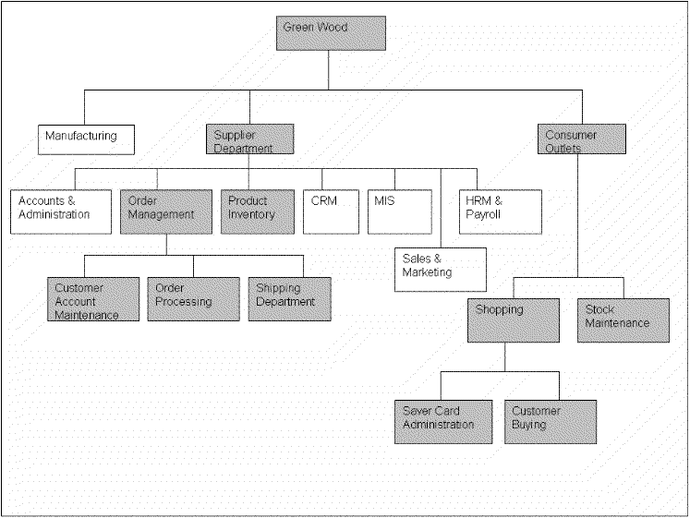

2.4. Usecase Diagram of Your Project:
A use case scenario is a visual description, typically written in structured English or point form, of a potential business situation that a system may or may not be able to handle.
A use case defines a goal-oriented set of interactions between external actors and the system under consideration.
A use case is initiated by a user with a particular goal in mind, and completes successfully when that goal is satisfied. It describes the sequence of interactions between actors and the system necessary to deliver the service that satisfies the goal. It also includes possible variants of this sequence, e.g., alternative sequences that may also satisfy the goal, as well as sequences that may lead to failure to complete the service because of exceptional behavior, error handling, etc. The system is treated as a “black box”, and the interactions with system, including system responses, are as perceived from outside the system.
Thus, use cases capture who (actor) does what (interaction) with the system, for what purpose (goal), without dealing with system internals. A complete set of use cases specifies all the different ways to use the system, and therefore defines all behavior required of the system, bounding the scope of the system.
Generally, use case steps are written in an easy-to-understand structured narrative using the vocabulary of the domain. This is engaging for users who can easily follow and validate the use cases, and the accessibility encourages users to be actively involved in defining the requirements.

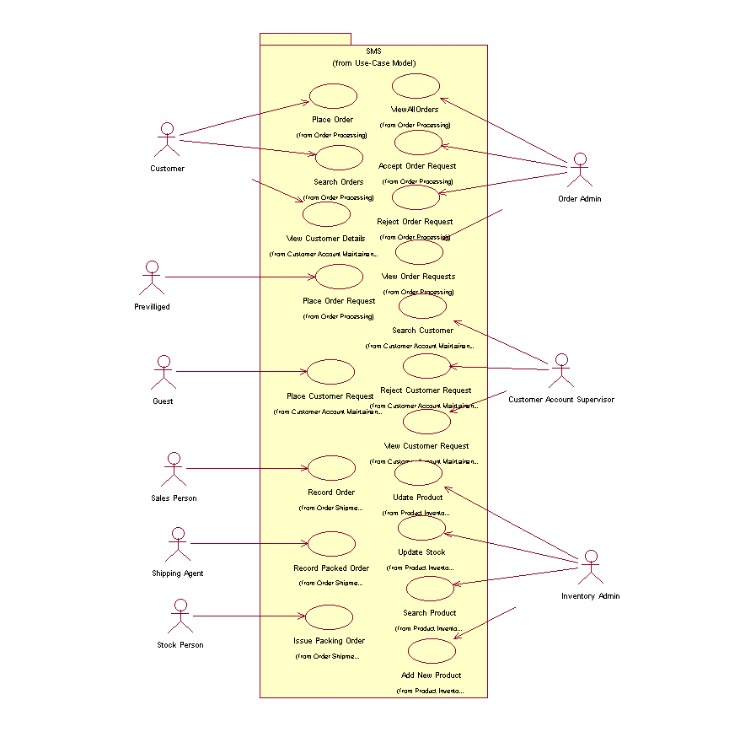
Example:

2.4.1. Usecase Description
While technically not part of UML, use case documents are closely related to UML use cases. A use case document is text that captures the detailed functionality of a use case. Such documents typically contain the following parts:

Brief description
Used to describe the overall intent of the use case. Typically, the brief description is only a few paragraphs, but it can be longer or shorter as needed. It describes what is considered the happy path—the functionality that occurs when the use case executes without errors. It can include critical variations on the happy path, if needed.

Preconditions
Conditionals that must be true before the use case can begin to execute. Note that this means the author of the use case document does not need to check these conditions during the basic flow, as they must be true for the basic flow to begin.

Basic flow
Used to capture the normal flow of execution through the use case. The basic flow is often represented as a numbered list that describes the interaction between an actor and the system. Decision points in the basic flow branch off to alternate flows. Use case extension points and inclusions are typically documented in the basic flow.

Alternate flows
Used to capture variations to the basic flows, such as user decisions or error conditions. There are typically multiple alternate flows in a single use case. Some alternate flows rejoin the basic flow at a specified point, while others terminate the use case.

Post conditions
Conditions that must be true for the use case to completed. Post conditions are typically used by the testers to verify that the realization of the use case is implemented correctly.

Chapter 3: Design Document (For Object Oriented Approach)

Introduction:
Second deliverable is all about the software design. In the previous deliverable, analysis of the system is completed. So we understand the current situation of the problem domain. Now we are ready to strive for a solution for the problem domain by using object-oriented approach. Following artifacts must be included in the 3rd deliverable.

- Domain Model
- Design Class Diagram
- Sequence Diagram
- State Chart Diagram
- Collaboration Diagram

Now we discuss these artifacts one by one as follows:

Domain Model
Domain models represent the set of requirements that are common to systems within a product line. There may be many domains, or areas of expertise, represented in a single product line and a single domain may span multiple product lines. The requirements represented in a domain model include:

- Definition of scope for the domain
- Information or objects
- Features or use cases, including factors that lead to variation
- Operational/behavioral characteristics

A product line definition will describe the domains necessary to build systems in the product line.

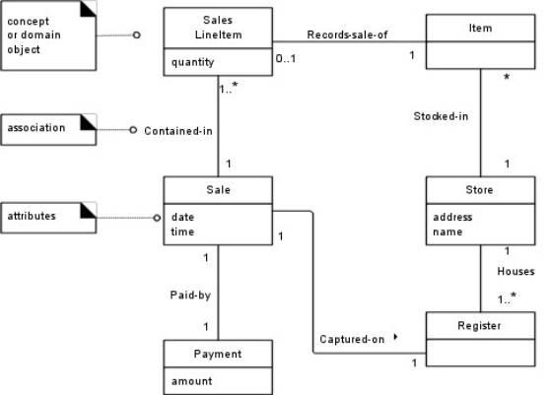

Design Class Diagram
Classes are the work-horses of the design effort—they actually perform the real work of the system. The other design elements—subsystems, packages and collaborations simply describe how classes are grouped or how they interoperate.
Capsules are also stereotyped classes, used to represent concurrent threads of execution in real-time systems. In such cases, other design classes are 'passive' classes, used within the execution context provided by the 'active' capsules. When the software architect and designer choose not to use a design approach based on capsules, it is still possible to model concurrent behavior using 'active' classes.
Active classes are design classes, which coordinate and drive the behavior of the passive classes - an active class is a class whose instances are active objects, owning their own thread of control.

Operations are required to support the messages that appear on sequence diagrams because scripts; messages (temporary message specifications) which have not yet been assigned to operations describe the behavior the class is expected to perform. An example class diagram is shown below:
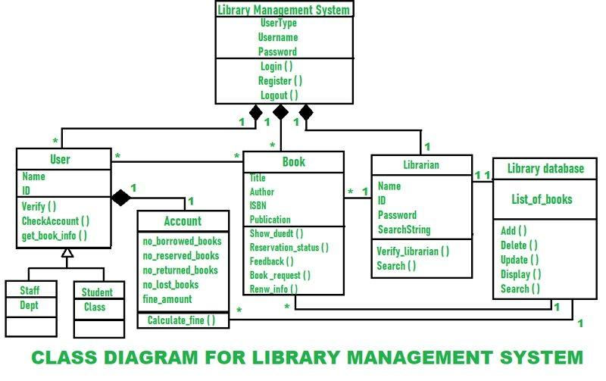
2nd Example

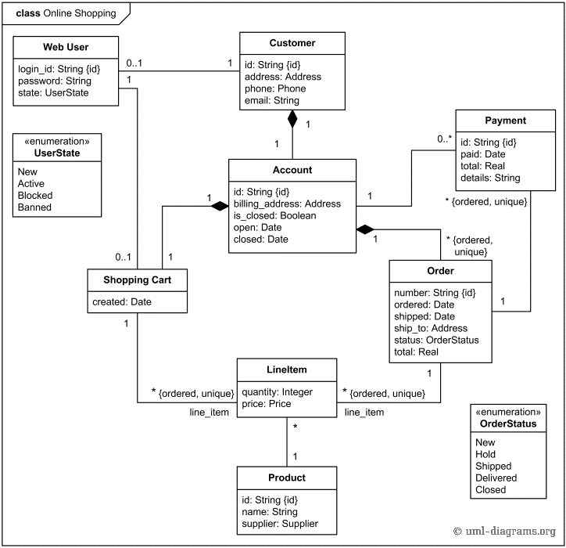

Sequence Diagram

A Sequence diagram depicts the sequence of actions that occur in a system. The invocation of methods in each object, and the order in which the invocation occurs is captured in a Sequence diagram. This makes the Sequence diagram a very useful tool to easily represent the dynamic behavior of a system.
A Sequence diagram is two-dimensional in nature. On the horizontal axis, it shows the life of the object that it represents, while on the vertical axis, it shows the sequence of the creation or invocation of these objects.
Because it uses class name and object name references, the Sequence diagram is very useful in elaborating and detailing the dynamic design and the sequence and origin of invocation of objects. Hence, the Sequence diagram is one of the most widely used dynamic diagrams in UML.

Example
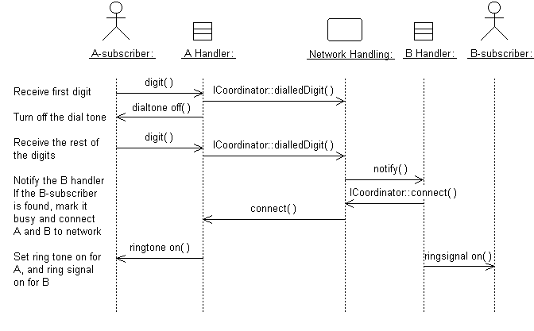
A sequence diagram that describes part of the flow of events of the use case Place Local Call in a simple Phone Switch.

Distributing Control Flow in Sequence Diagrams

Centralized control of a flow of events or part of the flow of events means that a few objects steer the flow by sending messages to, and receiving messages from other objects. These controlling objects decide the order in which other objects will be activated in the use case. Interaction among the rest of the objects is very minor or does not exist.

State chart diagram
For some operations, the behavior of the operation depends upon the state the receiver object is in. A state machine is a tool for describing the states the object can assume and the events that cause the object to move from one state to another. State machines are most useful for describing active classes. The use of state machines is particularly important for defining the behavior. An example of a simple state machine is shown below:

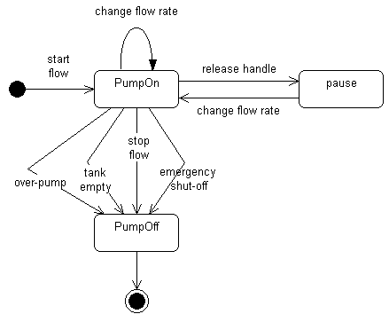

Each state transition event can be associated with an operation. Depending on the object's state, the operation may have a different behavior; the transition events describe how this occurs.
The method description for the associated operation should be updated with the state-specific information, indicating, for each relevant state, what the operation should do. States are often represented using attributes; the statechart diagrams serve as input into the attribute identification step.

Collaboration Diagram
A collaboration diagram describes a pattern of interaction among objects; it shows the objects participating in the interaction by their links to each other and the messages that they send to each other.
Collaboration diagrams are used to show how objects interact to perform the behavior of a particular use case, or a part of a use case. Along with sequence diagrams, collaborations are used by designers to define and clarify the roles of the objects that perform a particular flow of events of a use case. They are the primary source of information used to determining class responsibilities and interfaces.
Unlike a sequence diagram, a collaboration diagram shows the relationships among the objects. Sequence diagrams and collaboration diagrams express similar information, but show it in different ways. Collaboration diagrams show the relationships among objects and are better for understanding all the effects on a given object and for procedural design.
Because of the format of the collaboration diagram, they tend to better suited for analysis activities. Specifically, they tend to be better suited to depicting simpler interactions of smaller numbers of objects. As the number of objects and messages grows, the diagram becomes increasingly hard to read. In addition, it is difficult to show additional descriptive information such as timing, decision points, or other unstructured information that can be easily added to the notes in a sequence diagram.

Contents of Collaboration Diagrams
You can have objects and actor instances in collaboration diagrams, together with links and messages describing how they are related and how they interact. The diagram describes what takes place in the participating objects, in terms of how the objects communicate by sending messages to one another. You can make a collaboration diagram for each variant of a use case's flow of events.

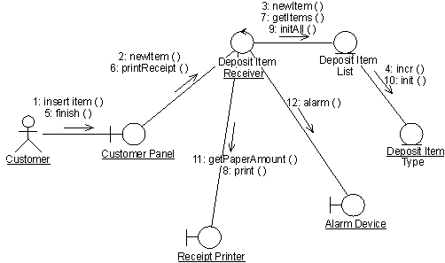

A collaboration diagram that describes part of the flow of events of the use case Receive Deposit Item in the Recycling-Machine System.

Chapter 4: User Interface Design

4.1. Introduction

A user interface design consists of three main parts:
Page elements should be visualized on paper before building them in the computer. Just as you draw a site map to plan the site, use cartoons and storyboards to begin blocking out the site’s appearance and navigational scheme.

- Site maps
- Storyboards
- Navigational maps

4.2. Site Maps
A site map's main benefit is to give users an overview of the site's areas in a single glance by dedicating an entire page to a visualization of the information architecture. If designed well, this overview can include several levels of hierarchy, and yet not be so big that users lose their ability to grasp the map as a whole. Some of the site maps we studied stretched over six screens on a standard 800x600 monitor. This is much too much. We recommend keeping the site map short; it should be no more than two-and-a-half times the window size most common among your users.
The greatest failures in our study came from site maps that attempted to lure the user into a dynamically twisting and expanding view, rather than presenting a simple, static representation of the information architecture. The site map's goal is to give users a single overview of the information space. If users have to work to reveal different parts of the map, that benefit is lost.
Dynamic site maps are basically an alternative way of navigating through the information space using a set of non-standard interaction techniques. For example, one site used a hyperbolic tree, where users had to click and drag clusters of links around the screen to expand areas of interest. Nobody could do this well.
A site map should not be a navigational challenge of its own. It should be a map.
As we have found again and again, users hated non-standard user interfaces that forced them to learn a special way of doing things for the sake of a single website. Site maps should be simple, compact layouts of links, and they should show everything in a single view.
If your site is large and complex, it is a good idea to include and index or site map that provides an outline of our site's content. This concept is something that we are all familiar with in the print world and it is very useful on the Web. An index is usually an alphabetical listing of key words that link to the appropriate pages in the site or it can be more like a table of contents. A site map is a graphical representation of the site's content. It doesn't usually have as much detailed information as the index has.
As web sites get more complicated, an index or site map is going to become more and more valuable and essential to the navigation of a good site.

4.3. Story boards
A storyboard is a sequence of single images, each of which represents a distinct event or narrative. It is also a visual representation of the script illustrating the interaction between the user and the machine. It can also be imagined as a film in visual-outline form.
A storyboard can be used in two ways. It describes the task, which are a series of images showing the user, environment and the machine. It also describes the interface, which represent series of screen images indicating the user’s representation and the computer’s response and work out interaction details when asking, “what happens next?” It also shows interaction sequence at a glance and helps develop usage scenarios to help develop tools & tasks.
All this can be done to construct a visual & verbal sequence that illustrates the interaction. Consider …

- Environment -- where system is used
- Visual cues -- what user can see
- Audible cues -- what user can hear
- Tactile cues -- what user can touch
- User input -- how the user communicates to the machine
- Machine output -- how the machine responds to the user
- User’s emotions -- how user perceives and responds to the interaction
- Technology -- what technology is involved in performing the task
- Quality of experience -- what benefit is perceived

HOW?
- Use a grid that puts the graphic representation above and the verbal description below
- Begin with loose thumbnail sketches and drawing for early design concepts. Refine with tighter drawings and screen designs for presentation and testing.
- Describe the interaction details and emotional responses verbally when no visual representation is effective
- Keep the medium loose and flexible in the conceptual design phase

These are the detailed screens, which pictorially represent the complete view of the screens. There would be symbols representing the different elements of the screens and in the end an index that would detail the symbols. Sample is given on the next page.

S1: Microsoft Products

S2: Username

S3: Password

T1:

T2:

B1: Submit

S1: static button 1
S2: static button 2
S3: static button 3
T1: text box 1
T2: text box 2
B1: button

4.4. Navigational maps:
The next step is of navigational maps. In these maps, the storyboards are used as an input. The different display buttons or action buttons show the navigation from one screen to the other. In other words when one action button is pressed it would lead to other screens. This path and navigation would be shown.

Chapter 5: Software Testing

5.1 Introduction:
This deliverable is based on the IEEE standard of software testing i.e. IEEE SOFTWARE TEST DOCUMENTATION Std 829-1998. This standard describes a set of basic test documents that are associated with the dynamic aspects of software testing (i.e., the execution of procedures and code). The standard defines the purpose, outline, and content of each basic document. While the documents described in the standard focus on dynamic testing, several of them may be applicable to other testing activities (e.g., the test plan and test incident report may be used for design and code reviews). This standard may be applied to commercial, scientific, or military software that runs on any digital computer. Applicability is not restricted by the size, complexity, or criticality of the software. However, the standard does not specify any class of software to which it must be applied. The standard addresses the documentation of both initial development testing and the testing of subsequent software releases. For a particular software release, it may be applied to all phases of testing from module testing through user acceptance. However, since all of the basic test documents may not be useful in each test phase, the particular documents to be used in a phase are not specified. Each organization using the standard will need to specify the classes of software to which it applies and the specific documents required for a particular test phase.

The standard does not call for specific testing methodologies, approaches, techniques, facilities, or tools, and does not specify the documentation of their use. Additional test documentation may be required (e.g., code inspection checklists and reports). The standard also does not imply or impose specific methodologies for documentation control, configuration management, or quality assurance. Additional documentation (e.g., a quality assurance plan) may be needed depending on the particular methodologies used.

Following are standard artifacts, which must be included in this deliverable:
- Test Plan
- Test Design Specification
- Test Case Specification
- Test Procedure Specification
- Test Item Transmittal Report
- Test Log
- Test Incident Report
- Test Summary Report

5.2. Test plan

5.2.1. Purpose
To prescribe the scope, approach, resources, and schedule of the testing activities. To identify the items being tested, the features to be tested, the testing tasks to be performed, the personnel responsible for each task, and the risks associated with this plan.

5.2.2. Outline
A test plan shall have the following structure:

- Test plan identifier
- Introduction
- Test items
- Features to be tested
- Features not to be tested
- Approach
- Item pass/fail criteria
- Suspension criteria and resumption requirements
- Test deliverables
- Testing tasks
- Environmental needs
- Responsibilities
- Staffing and training needs
- Schedule
- Risks and contingencies
- Approvals

The sections shall be ordered in the specified sequence. Additional sections may be included immediately prior to Approvals. If some or all of the content of a section is in another document, then a reference to that material may be listed in place of the corresponding content. The referenced material must be attached to the test plan or available to users of the plan.
Details on the content of each section are contained in the following sub-clauses.

5.2.2.1. Test plan identifier
Specify the unique identifier assigned to this test plan.

5.2.2.2. Introduction
Summarize the software items and software features to be tested. The need for each item and its history may be included. References to the following documents, when they exist, are required in the highest-level test plan:

- Project authorization;
- Project plan;
- Quality assurance plan;
- Configuration management plan;
- Relevant policies;
- Relevant standards.

In multilevel test plans, each lower-level plan must reference the next higher-level plan.

5.2.2.3. Test items
Identify the test items including their version/revision level. Also specify characteristics of their transmittal media that impact hardware requirements or indicate the need for logical or physical transformations before testing can begin (e.g., programs must be transferred from tape to disk).
Supply references to the following test item documentation, if it exists:

a) Requirements specification
b) Design specification
c) Users guide
d) Operations guide
e) Installation guide
Reference any incident reports relating to the test items. Items that are to be specifically excluded from testing may be identified.

5.2.2.4. Features to be tested
Identify all software features and combinations of software features to be tested. Identify the test design specification associated with each feature and each combination of features.

5.2.2.5. Features not to be tested
Identify all features and significant combinations of features that will not be tested and the reasons.

5.2.2.6. Approach
Describe the overall approach to testing. For each major group of features or feature combinations, specify the approach that will ensure that these feature groups are adequately tested. Specify the major activities, techniques, and tools that are used to test the designated groups of features.
The approach should be described in sufficient detail to permit identification of the major testing tasks and estimation of the time required to do each one.
Specify the minimum degree of comprehensiveness desired. Identify the techniques that will be used to judge the comprehensiveness of the testing effort (e.g., determining which statements have been executed at least once). Specify any additional completion criteria (e.g., error frequency). The techniques to be used to trace requirements should be specified. Identify significant constraints on testing such as test item availability, testing resource availability, and deadlines.

5.2.2.7. Item pass/fail criteria
Specify the criteria to be used to determine whether each test item has passed or failed testing.

5.2.2.8. Suspension criteria and resumption requirements
Specify the criteria used to suspend all or a portion of the testing activity on the test items associated with this plan. Specify the testing activities that must be repeated, when testing is resumed.

5.2.2.9. Test deliverables
Identify the deliverable documents. The following documents should be included:
- Test plan;
- Test design specifications;
- Test case specifications;
- Test procedure specifications;
- Test item transmittal reports;
- Test logs;
- Test incident reports;
- Test summary reports.
Test input data and test output data should be identified as deliverables.
Test tools (e.g., module drivers and stubs) may also be included.

5.2.2.10. Testing tasks
Identify the set of tasks necessary to prepare for and perform testing. Identify all inter task dependencies and any special skills required.

5.2.2.11. Environmental needs
Specify both the necessary and desired properties of the test environment. This specification should contain the physical characteristics of the facilities including the hardware, the communications and system software, the mode of usage (e.g., stand-alone), and any other software or supplies needed to support the test. Also specify the level of security that must be provided for the test facilities, system software, and proprietary components such as software, data, and hardware. Identify special test tools needed.
Identify any other testing needs (e.g., publications or office space). Identify the source for all needs that are not currently available to the test group.

5.2.2.12. Responsibilities
Identify the groups responsible for managing, designing, preparing, executing, witnessing, checking, and resolving. In addition, identify the groups responsible for providing the test items identified in 7.2.2.3 and the environmental needs identified in 5.2.2.11.
These groups may include the developers, testers, operations staff, user representatives, technical support staff, data administration staff, and quality support staff.

5.2.2.13 Staffing and training needs
Specify test-staffing needs by skill level. Identify training options for providing necessary skills.

5.2.2.14. Schedule
Include test milestones identified in the software project schedule as well as all item transmittal events.
Define any additional test milestones needed. Estimate the time required to do each testing task. Specify the schedule for each testing task and test milestone. For each testing resource (i.e., facilities, tools, and staff), specify its periods of use.

5.2.2.15. Risks and contingencies
Identify the high-risk assumptions of the test plan. Specify contingency plans for each (e.g., delayed delivery of test items might require increased night shift scheduling to meet the delivery date).

5.2.2.16 Approvals
Specify the names and titles of all persons who must approve this plan. Provide space for the signatures and dates.

5.3. Test design specification

5.3.1. Purpose
To prescribe the scope, approach, resources, and schedule of the testing activities. To identify the items being tested, the features to be tested, the testing tasks to be performed, the personnel responsible for each task, and the risks associated with this plan.

5.3.2. Outline
A test plan shall have the following structure:

- Test plan identifier;
- Introduction;
- Test items;
- Features to be tested;
- Features not to be tested;
- Approach;
- Item pass/fail criteria;
- Suspension criteria and resumption requirements;
- Test deliverables;
- Testing tasks;
- Environmental needs;
- Responsibilities;
- Staffing and training needs;
- Schedule;
- Risks and contingencies;
- Approvals.

The sections shall be ordered in the specified sequence. Additional sections may be included immediately prior to Approvals. If some or all of the content of a section is in another document, then a reference to that material may be listed in place of the corresponding content. The referenced material must be attached to the test plan or available to users of the plan.
Details on the content of each section are contained in the following sub-clauses.

5.3.2.1 Test plan identifier
Specify the unique identifier assigned to this test plan.

5.3.2.2. Introduction
Summarize the software items and software features to be tested. The need for each item and its history may be included. References to the following documents, when they exist, are required in the highest-level test plan:

- Project authorization
- Project plan
- Quality assurance plan
- Configuration management plan
- Relevant policies
- Relevant standards

In multilevel test plans, each lower-level plan must reference the next higher-level plan.

5.3.2.3. Test items
Identify the test items including their version/revision level. Also specify characteristics of their transmittal media that impact hardware requirements or indicate the need for logical or physical transformations before testing can begin (e.g., programs must be transferred from tape to disk). Supply references to the following test item documentation, if it exists:

- Requirements specification
- Design specification
- Users guide
- Operations guide
- Installation guide

Reference any incident reports relating to the test items. Items that are to be specifically excluded from testing may be identified.

5.3.2.4. Features to be tested
Identify all software features and combinations of software features to be tested. Identify the test design specification associated with each feature and each combination of features.

5.3.2.5. Features not to be tested
Identify all features and significant combinations of features that will not be tested and the reasons.

5.3.2.6. Approach
Describe the overall approach to testing. For each major group of features or feature combinations, specify the approach that will ensure that these feature groups are adequately tested. Specify the major activities, techniques, and tools that are used to test the designated groups of features.
The approach should be described in sufficient detail to permit identification of the major testing tasks and estimation of the time required to do each one. Specify the minimum degree of comprehensiveness desired. Identify the techniques that will be used to judge the comprehensiveness of the testing effort (e.g., determining which statements have been executed at least once).
Specify any additional completion criteria (e.g., error frequency). The techniques to be used to trace requirements should be specified. Identify significant constraints on testing such as test item availability, testing resource availability, and deadlines.

5.3.2.7. Item pass/fail criteria
Specify the criteria to be used to determine whether each test item has passed or failed testing.

5.3.2.8. Suspension criteria and resumption requirements
Specify the criteria used to suspend all or a portion of the testing activity on the test items associated with this plan. Specify the testing activities that must be repeated, when testing is resumed.

5.3.2.9. Test deliverables
Identify the deliverable documents. The following documents should be included:
- Test plan
- Test design specifications
- Test case specifications
- Test procedure specifications
- Test item transmittal reports
- Test logs
- Test incident reports
- Test summary reports

Test input data and test output data should be identiÞed as deliverables. Test tools (e.g., module drivers and stubs) may also be included.

5.3.2.10. Testing tasks
Identify the set of tasks necessary to prepare for and perform testing. Identify all inter task dependencies and any special skills required.

5.3.2.11. Environmental needs
Specify both the necessary and desired properties of the test environment. This specification should contain the physical characteristics of the facilities including the hardware, the communications and system software, the mode of usage (e.g., stand-alone), and any other software or supplies needed to support the test. Also specify the level of security that must be provided for the test facilities, system software, and proprietary components such as software, data, and hardware. Identify special test tools needed.
Identify any other testing needs (e.g., publications or office space). Identify the source for all needs that are not currently available to the test group.

5.3.2.12. Responsibilities
Identify the groups responsible for managing, designing, preparing, executing, witnessing, checking, and resolving. In addition, identify the groups responsible for providing the test items identified in 7.2.2.3 and the environmental needs identified in 5.3.2.11.
These groups may include the developers, testers, operations staff, user representatives, technical support staff, data administration staff, and quality support staff.

5.3.2.13. Staffing and training needs
Specify test-staffing needs by skill level. Identify training options for providing necessary skills.

5.3.2.14. Schedule
Include test milestones identified in the software project schedule as well as all item transmittal events. Define any additional test milestones needed. Estimate the time required to do each testing task. Specify the schedule for each testing task and test milestone. For each testing resource (i.e., facilities, tools, and staff), specify its periods of use.

5.3.2.15. Risks and contingencies
Identify the high-risk assumptions of the test plan. Specify contingency plans for each (e.g., delayed delivery of test items might require increased night shift scheduling to meet the delivery date)

5.3.2.16. Approvals
Specify the names and titles of all persons who must approve this plan. Provide space for the signatures and dates.

5.4. Test Case Specification

5.4.1. Purpose
To define a test case identified by a test design specification.

5.4.2. Outline
A test case specification shall have the following structure:

- Test case specification identifier
- Test items
- Input specifications
- Output specifications
- Environmental needs
- Special procedural requirements
- Inter case dependencies

The sections shall be ordered in the specified sequence. Additional sections may be included at the end. If some or all of the content of a section is in another document, then a reference to that material may be listed in place of the corresponding content. The referenced material must be attached to the test case specification or available to users of the case specification. Since a test case may be referenced by several test design specifications used by different groups over a long time period, enough specific information must be included in the test case specification to permit reuse.
Details on the content of each section are contained in the following sub-clauses.

5.4.2.1. Test case specification identifier
Specify the unique identifier assigned to this test case specification.

5.4.2.2 Test items
Identify and briefly describe the items and features to be exercised by this test case.
For each item, consider supplying references to the following test item documentation:
- Requirements specification
- Design specification
- Users guide
- Operations guide
- Installation guide

5.4.2.3. Input specifications
Specify each input required to execute the test case. Some of the inputs will be specified by value (with tolerances where appropriate), while others, such as constant tables or transaction files, will be specified by name. Identify all appropriate databases, files, terminal messages, memory resident areas, and values passed by the operating system.
Specify all required relationships between inputs (e.g., timing).

5.4.2.4. Output specifications
Specify all of the outputs and features (e.g., response time) required of the test items. Provide the exact value (with tolerances where appropriate) for each required output or feature.

5.4.2.5. Environmental needs

5.4.2.5.1. Hardware
Specify the characteristics and configurations of the hardware required to execute this test case (e.g., 132 character´ 24 line CRT).

5.4.2.5.2. Software
Specify the system and application software required to execute this test case. This may include system software such as operating systems, compilers, simulators, and test tools. In addition, the test item may interact with application software.

5.4.2.5.3. Other
Specify any other requirements such as unique facility needs or specially trained personnel.

5.4.2.6. Special procedural requirements
Describe any special constraints on the test procedures that execute this test case. These constraints may involve special set up, operator intervention, output determination procedures, and special wrap up.

5.4.2.7. Inter case dependencies
List the identifiers of test cases that must be executed prior to this test case. Summarize the nature of the dependencies.

5.5. Test procedure specification

5.5.1. Purpose
To specify the steps for executing a set of test cases or, more generally, the steps used to analyze a software item in order to evaluate a set of features.

5.5.2 Outline
A test procedure specification shall have the following structure:

- Test procedure specification identifier
- Purpose
- Special requirements
- Procedure steps

The sections shall be ordered in the specified sequence. Additional sections, if required, may be included at the end. If some or all of the content of a section is in another document, then a reference to that material may be listed in place of the corresponding content. The referenced material must be attached to the test procedure specification or available to users of the procedure specification.
Details on the content of each section are contained in the following sub clauses.

5.5.2.1. Test procedure specification identifier
Specify the unique identifier assigned to this test procedure specification. Supply a reference to the associated test design specification.

5.5.2.2. Purpose
Describe the purpose of this procedure. If this procedure executes any test cases, provide a reference for each of them. In addition, provide references to relevant sections of the test item documentation (e.g., references to usage procedures).

5.5.2.3. Special requirements
Identify any special requirements that are necessary for the execution of this procedure. These may include prerequisite procedures, special skills requirements, and special environmental requirements.

5.5.2.4. Procedure steps
Include the steps in 8.5.2.4.1. through 8.5.2.4.10 as applicable.

5.5.2.4.1. Log
Describe any special methods or formats for logging the results of test execution, the incidents observed, and any other events pertinent to the test (see Clauses 9 and 10).

5.5.2.4.2. Set up
Describe the sequence of actions necessary to prepare for execution of the procedure.

5.5.2.4.3. Start
Describe the actions necessary to begin execution of the procedure.

5.5.2.4.4. Proceed
Describe any actions necessary during execution of the procedure.

5.5.2.4.5. Measure
Describe how the test measurements will be made (e.g., describe how remote terminal response time is to be measured using a network simulator).

5.5.2.4.6. Shut down
Describe the actions necessary to suspend testing, when unscheduled events dictate.

5.5.2.4.7. Restart
Identify any procedural restart points and describe the actions necessary to restart the procedure at each of these points.

5.5.2.4.8. Stop
Describe the actions necessary to bring execution to an orderly halt.

5.5.2.4.9. Wrap up
Describe the actions necessary to restore the environment.

5.5.2.4..10. Contingencies
Describe the actions necessary to deal with anomalous events that may occur during execution.

5.6. Test item transmittal report

5.6.1. Purpose
To identify the test items being transmitted for testing. It includes the person responsible for each item, its physical location, and its status. Any variations from the current item requirements and designs are noted in this report.

5.6.2. Outline
A test item transmittal report shall have the following structure:

- Transmittal report identifier
- Transmitted items
- Location
- Status
- Approvals

The sections shall be ordered in the specified sequence. Additional sections may be included just prior to Approvals. If some or all of the content of a section is in another document, then a reference to that material may be listed in place of the corresponding content. The referenced material must be attached to the test item transmittal report or available to users of the transmittal report.
Details on the content of each section are contained in the following sub clauses.

5.6.2.1. Transmittal report identifier
Specify the unique identifier assigned to this test item transmittal report.

5.6.2.2. Transmitted items
Identify the test items being transmitted, including their version/revision level. Supply references to the item documentation and the test plan relating to the transmitted items. Indicate the people responsible for the transmitted items.

5.6.2.3. Location
Identify the location of the transmitted items. Identify the media that contain the items being transmitted. When appropriate, indicate how specific media are labeled or identified.

5.6.2.4. Status
Describe the status of the test items being transmitted. Include deviations from the item documentation, from previous transmittals of these items, and from the test plan. List the incident reports that are expected to be resolved by the transmitted items. Indicate if there are pending modifications to item documentation that may affect the items listed in this transmittal report.

5.6.2.5. Approvals
Specify the names and titles of all persons who most approve this transmittal. Provide space for the signatures and dates.

5.7. Test log

5.7.1. Purpose
To provide a chronological record of relevant details about the execution of tests.

5.7.2. Outline
A test log shall have the following structure:
- Test log identifier;
- Description;
- Activity and event entries.

The sections shall be ordered in the specified sequence. Additional sections may be included at the end. If some or all of the content of a section is in another document, then a reference to that material may be listed in place of the corresponding content. The referenced material must be attached to the test log or available to users of the log. Details on the content of each section are contained in the following sub clauses.

5.7.2.1. Test log identifier
Specify the unique identifier assigned to this test log.

5.7.2.2. Description
Information that applies to all entries in the log except as specifically noted in a log entry should be included here. The following information should be considered:
- Identify the items being tested including their version/revision levels. For each of these items, supply a reference to its transmittal report, if it exists.
- Identify the attributes of the environments in which the testing is conducted. Include facility identification, hardware being used (e.g., amount of memory being used, CPU model number, and number and model of tape drives, and/or mass storage devices), system software used, and resources available (e.g., the amount of memory available).

5.7.2.3. Activity and event entries
For each event, including the beginning and end of activities, record the occurrence date and time along with the identity of the author. The information in 9.2.3.1 through 9.2.3.5 should be considered:

5.7.2.3.1. Execution description
Record the identifier of the test procedure being executed and supply a reference to its specification. Record all personnel present during the execution including testers, operators, and observers. Also indicate the function of each individual.

5.7.2.3.2. Procedure results
For each execution, record the visually observable results (e.g., error messages generated, aborts, and requests for operator action). Also record the location of any output (e.g., reel number). Record the successful or unsuccessful execution of the test.

5.7.2.3.3. Environmental information
Record any environmental conditions specific to this entry (e.g., hardware substitutions).

5.7.2.3.4. Anomalous events
Record what happened before and after an unexpected event occurred (e.g., A summary display was requested and the correct screen displayed, but response seemed unusually long. A repetition produced the same prolonged response). Record circumstances surrounding the inability to begin execution of a test procedure or failure to complete a test procedure (e.g., a power failure or system software problem).

5.7.2.3.5. Incident report identifiers
Record the identifier of each test incident report, whenever one is generated.

5.8. Test incident report

5.8.1. Purpose
To document any event that occurs during the testing process that requires investigation.

5.8.2. Outline
A test incident report shall have the following structure:

- Test incident report identifier
- Summary
- Incident description
- Impact

The sections shall be ordered in the specified sequence. Additional sections may be included at the end. If some or all of the content of a section is in another document, then a reference to that material may be listed in place of the corresponding content. The referenced material must be attached to the test incident report or available to users of the incident report.
Details on the content of each section are contained in the following sub clauses.

5.8.2.1. Test incident report identifier
Specify the unique identifier assigned to this test incident report.

5.8.2.2. Summary
Summarize the incident. Identify the test items involved indicating their version/revision level. References to
the appropriate test procedure specification, test case specification, and test log should be supplied.

5.8.2.3. Incident description
Provide a description of the incident. This description should include the following items:
- Inputs
- Expected results
- Actual results
- Anomalies
- Date and time;
- Procedure step;
- Environment;
- Attempts to repeat;
- Testers;
- Observers.

Related activities and observations that may help to isolate and correct the cause of the incident should be included (e.g., describe any test case executions that might have a bearing on this particular incident and any variations from the published test procedure).

5.8.2.4.Impact
If known, indicate what impact this incident will have on test plans, test design specifications, test procedure specifications, or test case specifications.

5.9. Test summary report

5.9.1. Purpose
To summarize the results of the designated testing activities and to provide evaluations based on these results.

5.9.2. Outline
A test summary report shall have the following structure:
- Test summary report identifier
- Summary
- Variances
- Comprehensive assessment
- Summary of results
- Evaluation
- Summary of activities
- Approvals

The sections shall be ordered in the specified sequence. Additional sections may be included just prior to Approvals. If some or all of the content of a section is in another document, then a reference to that material may be listed in place of the corresponding content. The referenced material must be attached to the test summary report or available to users of the summary report.
Details on the content of each section are contained in the following sub clauses.

5.9.2.1. Test summary report identifier
Specify the unique identifier assigned to this test summary report.

5.9.2.2. Summary
Summarize the evaluation of the test items. Identify the items tested, indicating their version/revision level. Indicate the environment in which the testing activities took place.
For each test item, supply references to the following documents if they exist: test plan, test design specifications, test procedure specifications, test item transmittal reports, test logs, and test incident reports.

5.9.2.3. Variances
Report any variances of the test items from their design specifications. Indicate any variances from the test plan, test designs, or test procedures. Specify the reason for each variance.

5.9.2.4. Comprehensiveness assessment
Evaluate the comprehensiveness of the testing process against the comprehensiveness criteria specified in the test plan if the plan exists. Identify features or feature combinations that were not sufficiently tested and explain the reasons.

5.9.2.5. Summary of results
Summarize the results of testing. Identify all resolved incidents and summarize their resolutions. Identify all unresolved incidents.

5.9.2.6. Evaluation
Provide an overall evaluation of each test item including its limitations. This evaluation shall be based upon the test results and the item level pass/fail criteria. An estimate of failure risk may be included.

5.9.2.7. Summary of activities
Summarize the major testing activities and events. Summarize resource consumption data, e.g., total staffing level, total machine time, and total elapsed time used for each of the major testing activities.

5.9.2.8. Approvals
Specify the names and titles of all persons who must approve this report. Provide space for the signatures and dates.

Chapter 7: Results

Chapter 8: User Manual

Chapter 9: Conclusion and Future Work

